T-Shirt Sales
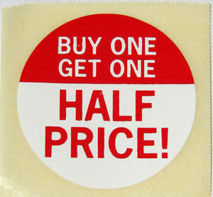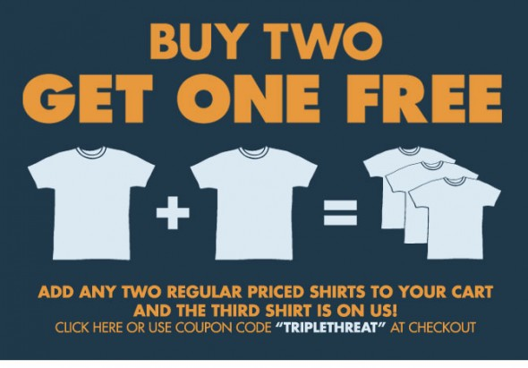
Tees-R-Us Sports-Mart

Your school wants to buy T-shirts.
Tees-R-Us has the sale “buy one, get one half off.”
Sport-Mart has the sale “buy two, get one free.”
Which is the better deal?

