Choosing a Slime Recipe

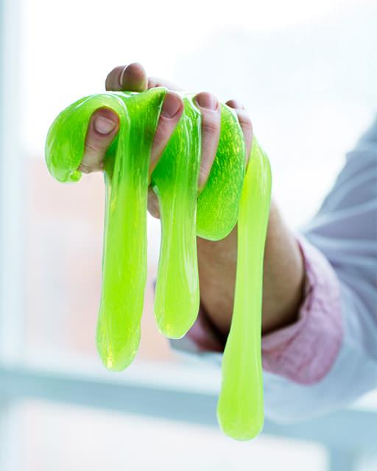

The 2nd graders are going to make slime for a science celebration. They need your help to decide which slime they should make.

Questions to think about:
  - What do you know that can help you figure this out?
  - What do you need to find out?
  - What assumptions do you have to make?

PART 1: Calculating Costs

First, the 2nd graders want to know how much it will cost to make each of the slime recipes.
- Use the information in “Cost of Slime Ingredients” table to calculate the cost for making a “class portion” of each type of slime.
- Write an equation to show how you figured out the cost of a “class portion” of each type of slime.
- Include unit labels so that it is clear what each number means.

Then add the cost to the “Comparing Slime Recipes” table.

PART 2: Comparing Slime Options

Cost it is not the only factor to consider.

Use the information in the “Comparing Slime Recipes” table to compare and contrast the different types of slimes.
- Decide which information is most important in your decision
- Use the information to rate and rank the different slime recipes

PART 3: Write a Recommendation:
- Tell the 2nd graders which slime recipe you think they should make for their science celebration, and why
- What information you considered in your decision, and what information (or factors) was the most important and the least important
- Your assumptions
- How much the slime will cost to make
- How others could use your plan to choose a slime recipe for their class

Use pictures, numbers and/or words to show that your plan will work.

Choosing a Slime Recipe (Part 1: Version B)

The 2nd graders are going to make slime for a science celebration. They need your help to decide which slime they should make.

How much will it cost?

We’re going to focus on three slime recipes:

Fluffy
Flubber
Glow in the Dark

We want to find out how much each type of slime would cost for one portion or for a class portion.

Keep in mind that ingredients are sold differently!

Use the information in the Task B Tables to determine the cost.

Explain the assumptions you made and show the mathematics you used.

