The Task: Animal Crackers for Snack

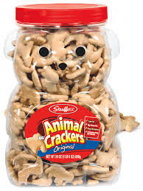

On Monday, your class gets a giant container of animal crackers to share for snack time. You have snack every day, and you want the animal crackers to last the whole week.

What can you do to make sure the animal crackers last all week? How can you figure out how many to give to each student?

Your plan to share the animal crackers must show:
- the animal crackers last for a week
- it is a fair plan
- your assumptions
- how you can use the plan in other sharing situations
Use pictures, numbers and words to communicate your plan.
Nutritional Information and Serving Size
