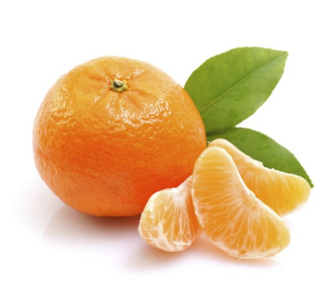
Mandarin Orange Task
The Healthy Snack Club at your school wants to buy mandarin oranges for snack time.
- How many 3 lb. bags of mandarin oranges should they buy if they want to give each student in your grade an orange?
- How many 5 lb. boxes of mandarin oranges would they buy if they want to give each student in your grade an orange?
- What will it cost the Healthy Snack Club to buy mandarin oranges for all of the students in your grade?

Package | Weight | Number of Oranges | Price
 | 2 pounds (lb) | 15-18 | $3.99
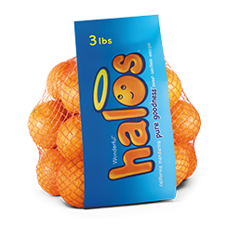 | 3 pounds (lb) |  | $5.49
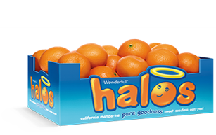 | 5 pounds (lb) |  | $8.75

Mandarin Orange Task Extension:
Consider other ways to buy enough oranges for your everyone in your grade.
  - Is your solution the least expensive solution? Why or why not?
  - If it is not the least expensive, how could you modify it so that it would cost less to buy
oranges for every student in your grade-level?

