The Pupusa Pricing Task 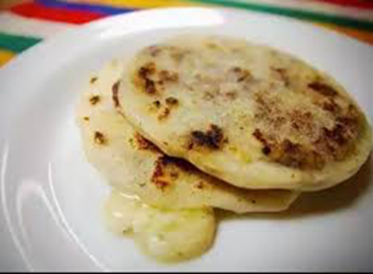
At City Market, the owner wants to update her menu. She needs to decide what types of pupusas to sell, and the price of each type of pupusa. She would like to sell a few different kinds of pupusas.
Maggie at City Café: “There’s a lot that I think about when I figure out the price of the pupusas. I use a mix for the Masa Harina, so that’s easy, but the ingredients of the different kinds of pupusa cost different amounts. Also if I make the arroz con pollo I have to spend more time cooking the chicken as an extra step. So that’s more labor cost. But I also want to keep the prices pretty low because people get more than 1. Most men – at least El Salvadorian men, get 6. Lots of women only get 3 .”
Your task is to recommend Pupusa Prices for the City Market menu. Use the information on the ingredient chart and recipe and :
- Select 2 different kinds of pupusas to put on the menu.
- Use mathematics to estimate the cost of making one pupusa (for each kind of pupusa you chose).
- Decide what price the owner should charge for each pupusa, so that she makes a profit, but also keeps prices low.
A note to the owner
- Write a note to the owner explaining your menu decisions and pricing recommendations. Use pictures, numbers and words.
- Include your assumptions.
- Tell the owner how she could use your method to set prices for other items she might want to sell at her pupuseria.

Basic Recipe:
To Make 4 to 6 pupusas
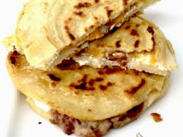
INGREDIENTS
- Masa harina -- 2 cups
- Warm water – 1 1/2 cups
- Filling – about 1 cup
PUPUSA VARIATIONS
- Pupusas de Queso: Fill the pupusa with grated cheese. Use quesillo, queso fresco, monterey jack, mozzarella, or a combination. Optional: Add green chile.
- Pupusas de Pollo con Queso: A filling of cheese and shredded chicken.
- Pupusas de Chicharrones: These pupusas are filled with chopped chicharrones, or ground, cooked pork
- Pupusas de Frijoles Refritos: Use either black or red refried beans. Optional: add cheese.
- Other fillings: cooked diced potatoes, or jalapeños

