Marshmallows for the Camping Trip - Task A
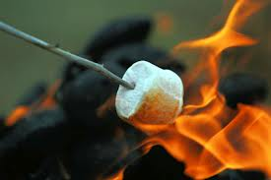
How many bags marshmallows do we need to buy
for the school camping trip?

What do we know? | What do we need to know?  How can we get that information? | What do we need to assume or decide?
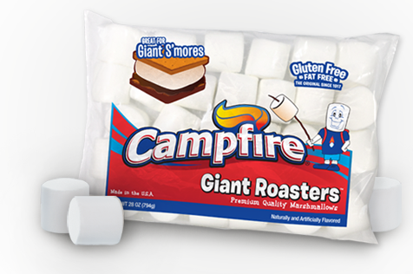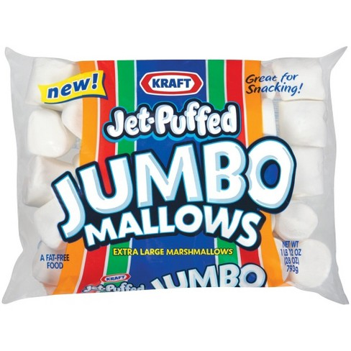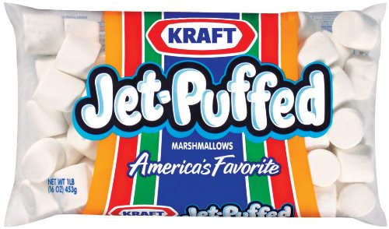

Make a plan that would help the camp organizers to buy enough bags of marshmallows with few leftovers.

PLAN CRITERIA
- Use pictures, words and numbers to show your plan.
- List your assumptions
- Explain how other groups could use your plan to figure out how many marshmallows they need for their camping trip.

Making S’Mores – Extension - Task B

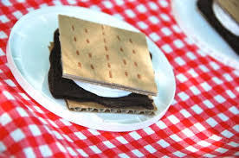

- What if we want to make S’Mores on the class camping trip?
- How many marshmallows do we need?
- How many boxes of graham crackers and chocolate bars would we need to make S’Mores on your grade-level camping trip?

