Making Picture Frames: ONE FRAME

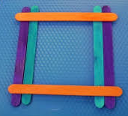 | 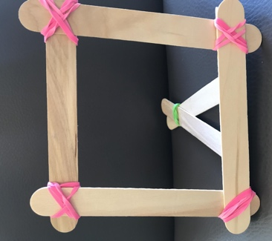 | 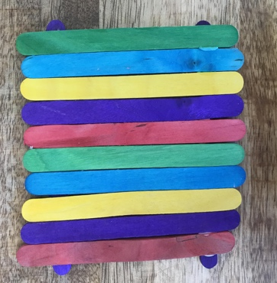
Sketch your Picture Frame here:

1. How many popsicle sticks do you need to make 1 frame?

Number of Plain Jumbo Sticks | Number of Multi-Color Sticks

2. What other materials do you need to make 1 frame?

How many magnets?

How many rubber bands?

How much ribbon?

Making Picture Frames: A CLASS DISPLAY

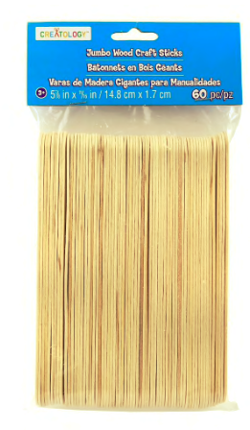  PLAIN JUMBO STICKS  60 PER PACKAGE | 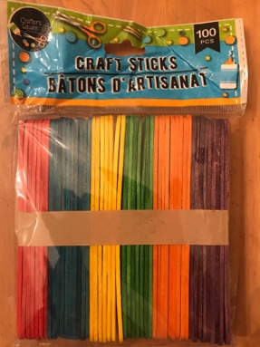  MULTICOLOR STICKS  100 PER PACKAGE

How many packages of popsicle sticks do you need so that every student in your class can make at least one picture frame (using your designs) for the class display?

We want to have enough popsicle sticks, but not many leftovers.

Your plan should explain:
- your assumptions and decisions
- which frame the class should make
- how many frames the class should make
- the number of packages of each type of popsicle stick needed for all the frames
- how many popsicle sticks you will have leftover
- how much of other materials needed to make all the frames

Use pictures, numbers, equations and words to show that your plan will work.
DESCRIBE YOUR FRAME: ____________________________________

How many of this frame will you make? ___________________________

 | How many sticks for one frame? | How many sticks for all the frames? | How many packages do we need? | How many sticks leftover?
Plain Jumbo Sticks

Multi-Color
Sticks

 | How many or how much for one frame? | How many or how much do we need for all the frames? | How many packages do we need? | How many or how much is leftover?
Other Material:

Other Material:

