Making “Bugs”: Warm Up!

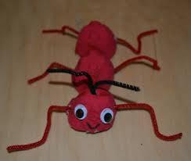 | 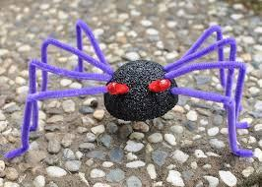 | 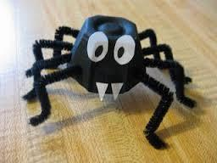 | 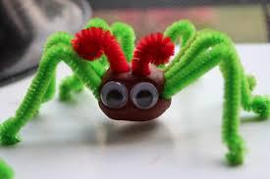
Draw your bug here:
1. How many whole fuzzy stems do you need to make 1 bug? _______

Explain how you figured this out.
Show how much of a fuzzy stem you need for each part of your bug.

2. How many containers of play dough do you need to make 1 bug? ______
Explain how you figured this out.

Making “Bugs” Part 1: Fuzzy Stems

How many packages of fuzzy stems do you need so that every student in your grade can make a bug?

- What do you know that can help you figure this out?
- What do you need to know?
- What do you need to assume?

Use pictures, numbers, equations and words to show that your plan will work.

Making “Bugs” Part 2: Play Dough Bodies

How many packages of play dough do you need so that every student in your grade can make a bug?

- What do you know that can help you figure this out?
- What do you need to know?
- What do you need to assume?

Use pictures, numbers, equations and words to show that your plan will work.

