Planning a Garden Task

Your school’s garden has an empty plot. The size of the plot is 4 feet by 8 feet.
Your class wants to plant vegetables in the plot. Your task is:

PART 1: Planning Your Garden
Decide which vegetables to plant and how many of each vegetable will fit in the plot.
Use the Planting a Square Foot Garden Table to help you.
Draw a picture or diagram to show your garden plan.

PART 2: Preparing the Soil

Square foot gardens need compost to enrich the soil.
Decide how much compost you will need for the 4 foot by 8 foot garden plot.
Use the information about Black Gold Garden Compost in the Chart below to determine how much the compost will cost.

Black Gold Garden Compost  1 bag holds 1 cubic ft of compost | 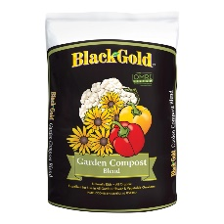 | $8.59/ bag

PART 3: Fencing Your Garden

You want to build a fence around the 4 foot by 8 foot garden plot to protect the vegetables from small animals.

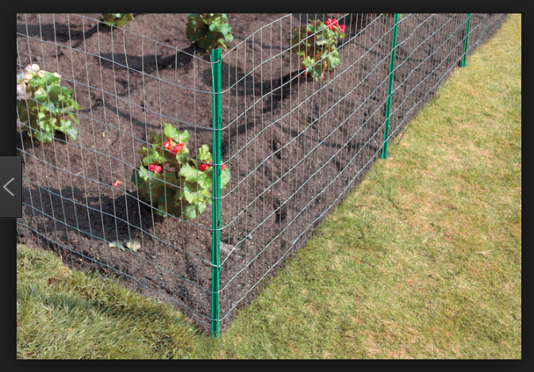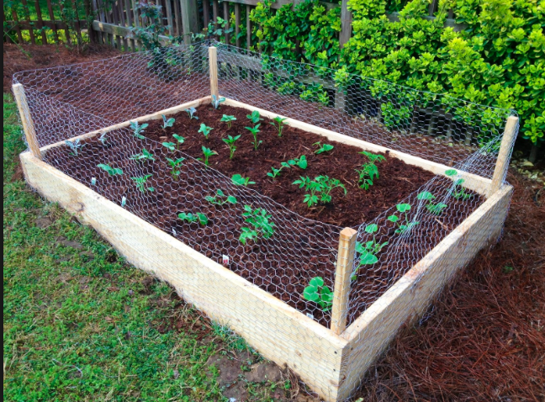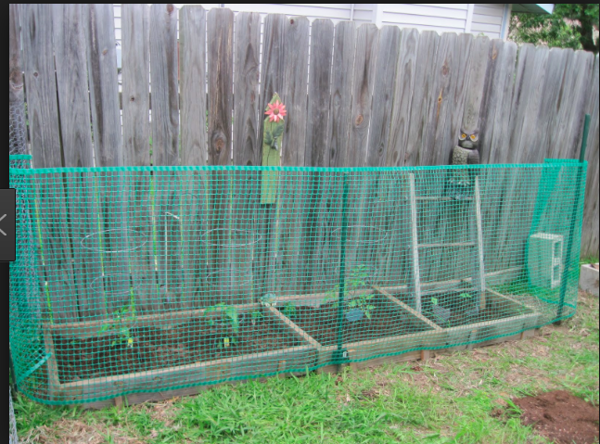

You will use stakes and fencing material to make the fence. You need to decide what kind of stakes to use, how far apart to place the stakes, and how many stakes you need. You also need to decide what type of fence material to use. You want the garden fence to be strong and stable, but also cost effective.

Make a plan for your garden fence.
Draw a picture or diagram of your plan. Show where you will place the stakes.
Estimate how much the fence will cost. Include the cost of stakes and fencing material.

STAKES
Item | Price | Pictures | Pictures
Green Rebar  Height: 24 inches | $1.47 per stake | 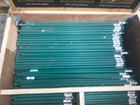 | 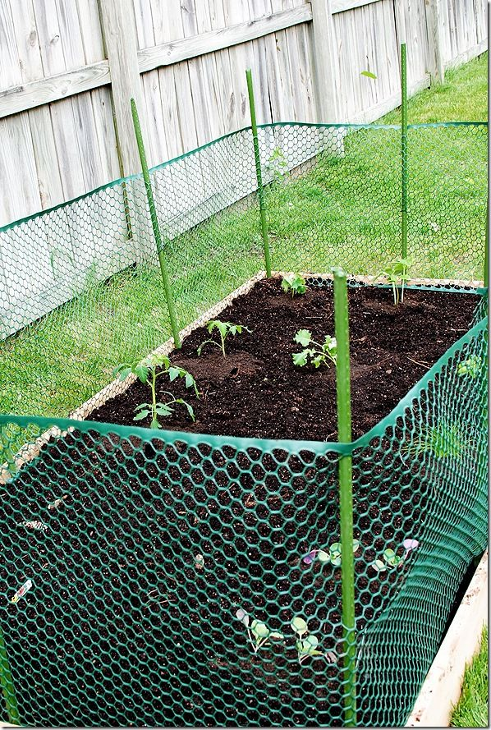
Narrow wooden stakes  Height: 35 ½ in  Width: 1 ⅜ inches | $7.98 per box  12 stakes in the box | 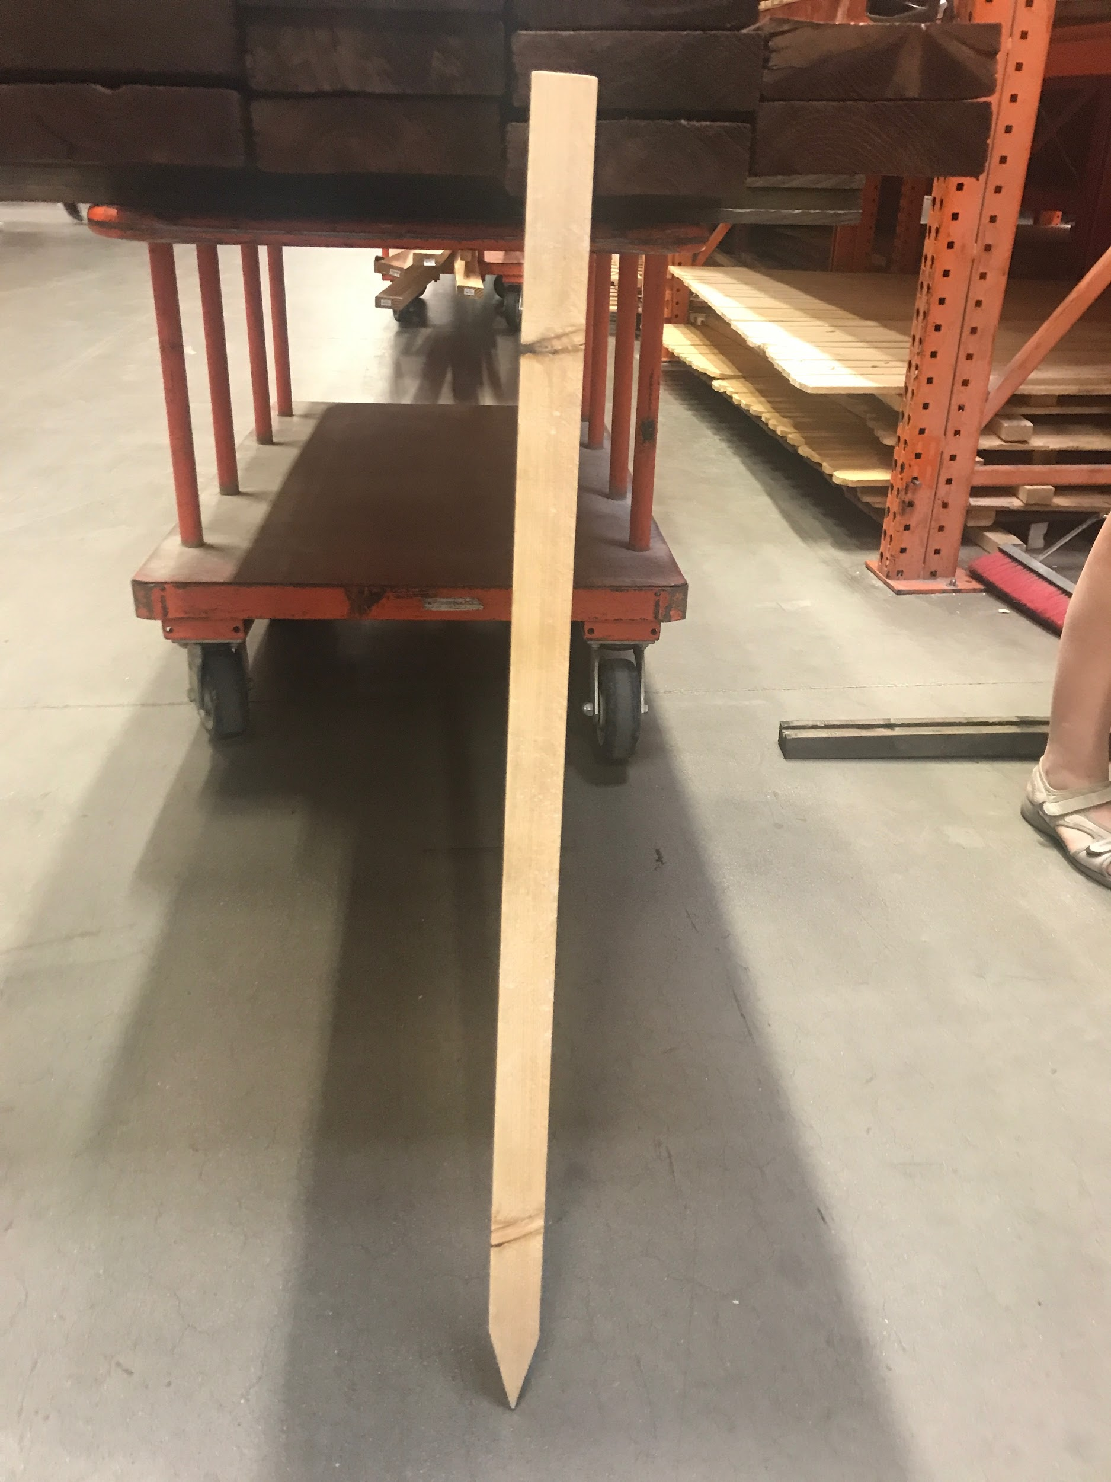 | 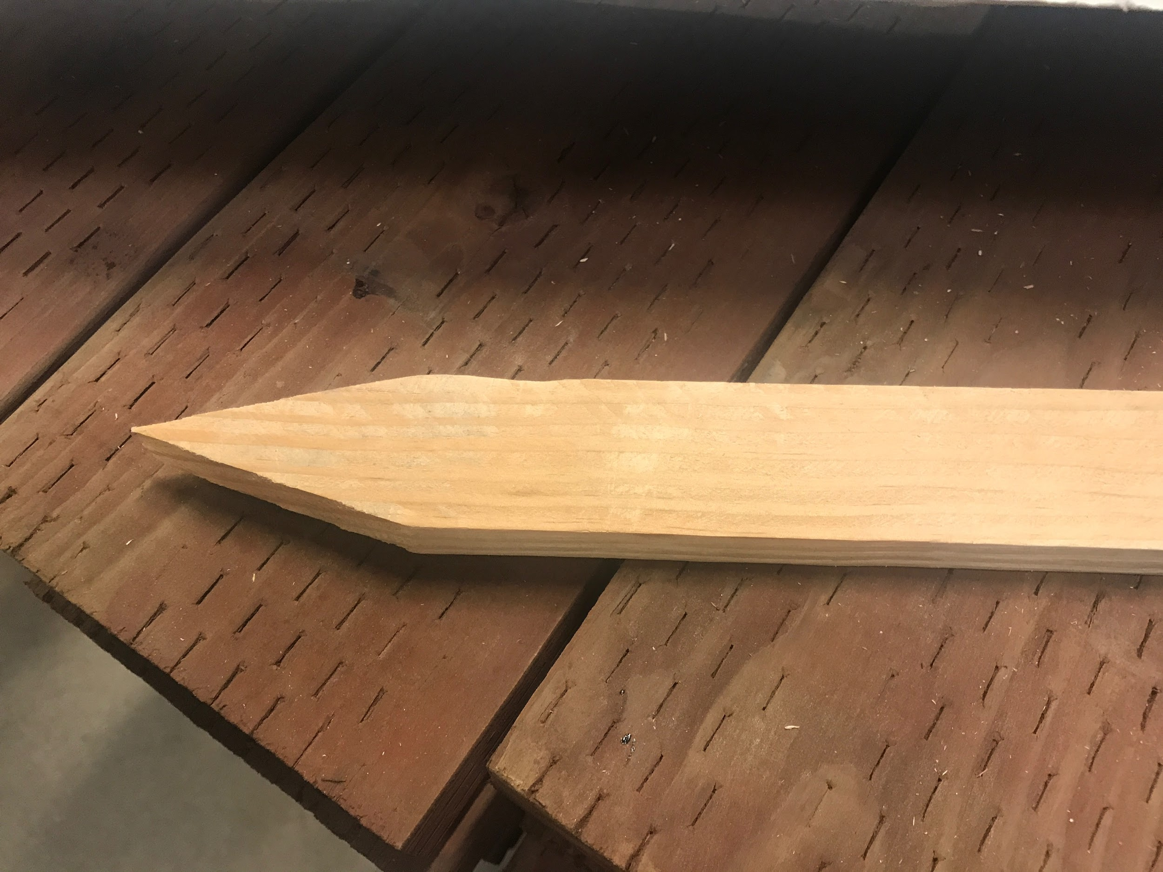
Wide wooden stakes  (pointed end)  Height: 42 ¼ inches  Width: 3 ½ inches | $1.23 per stake | 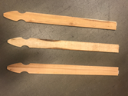 | 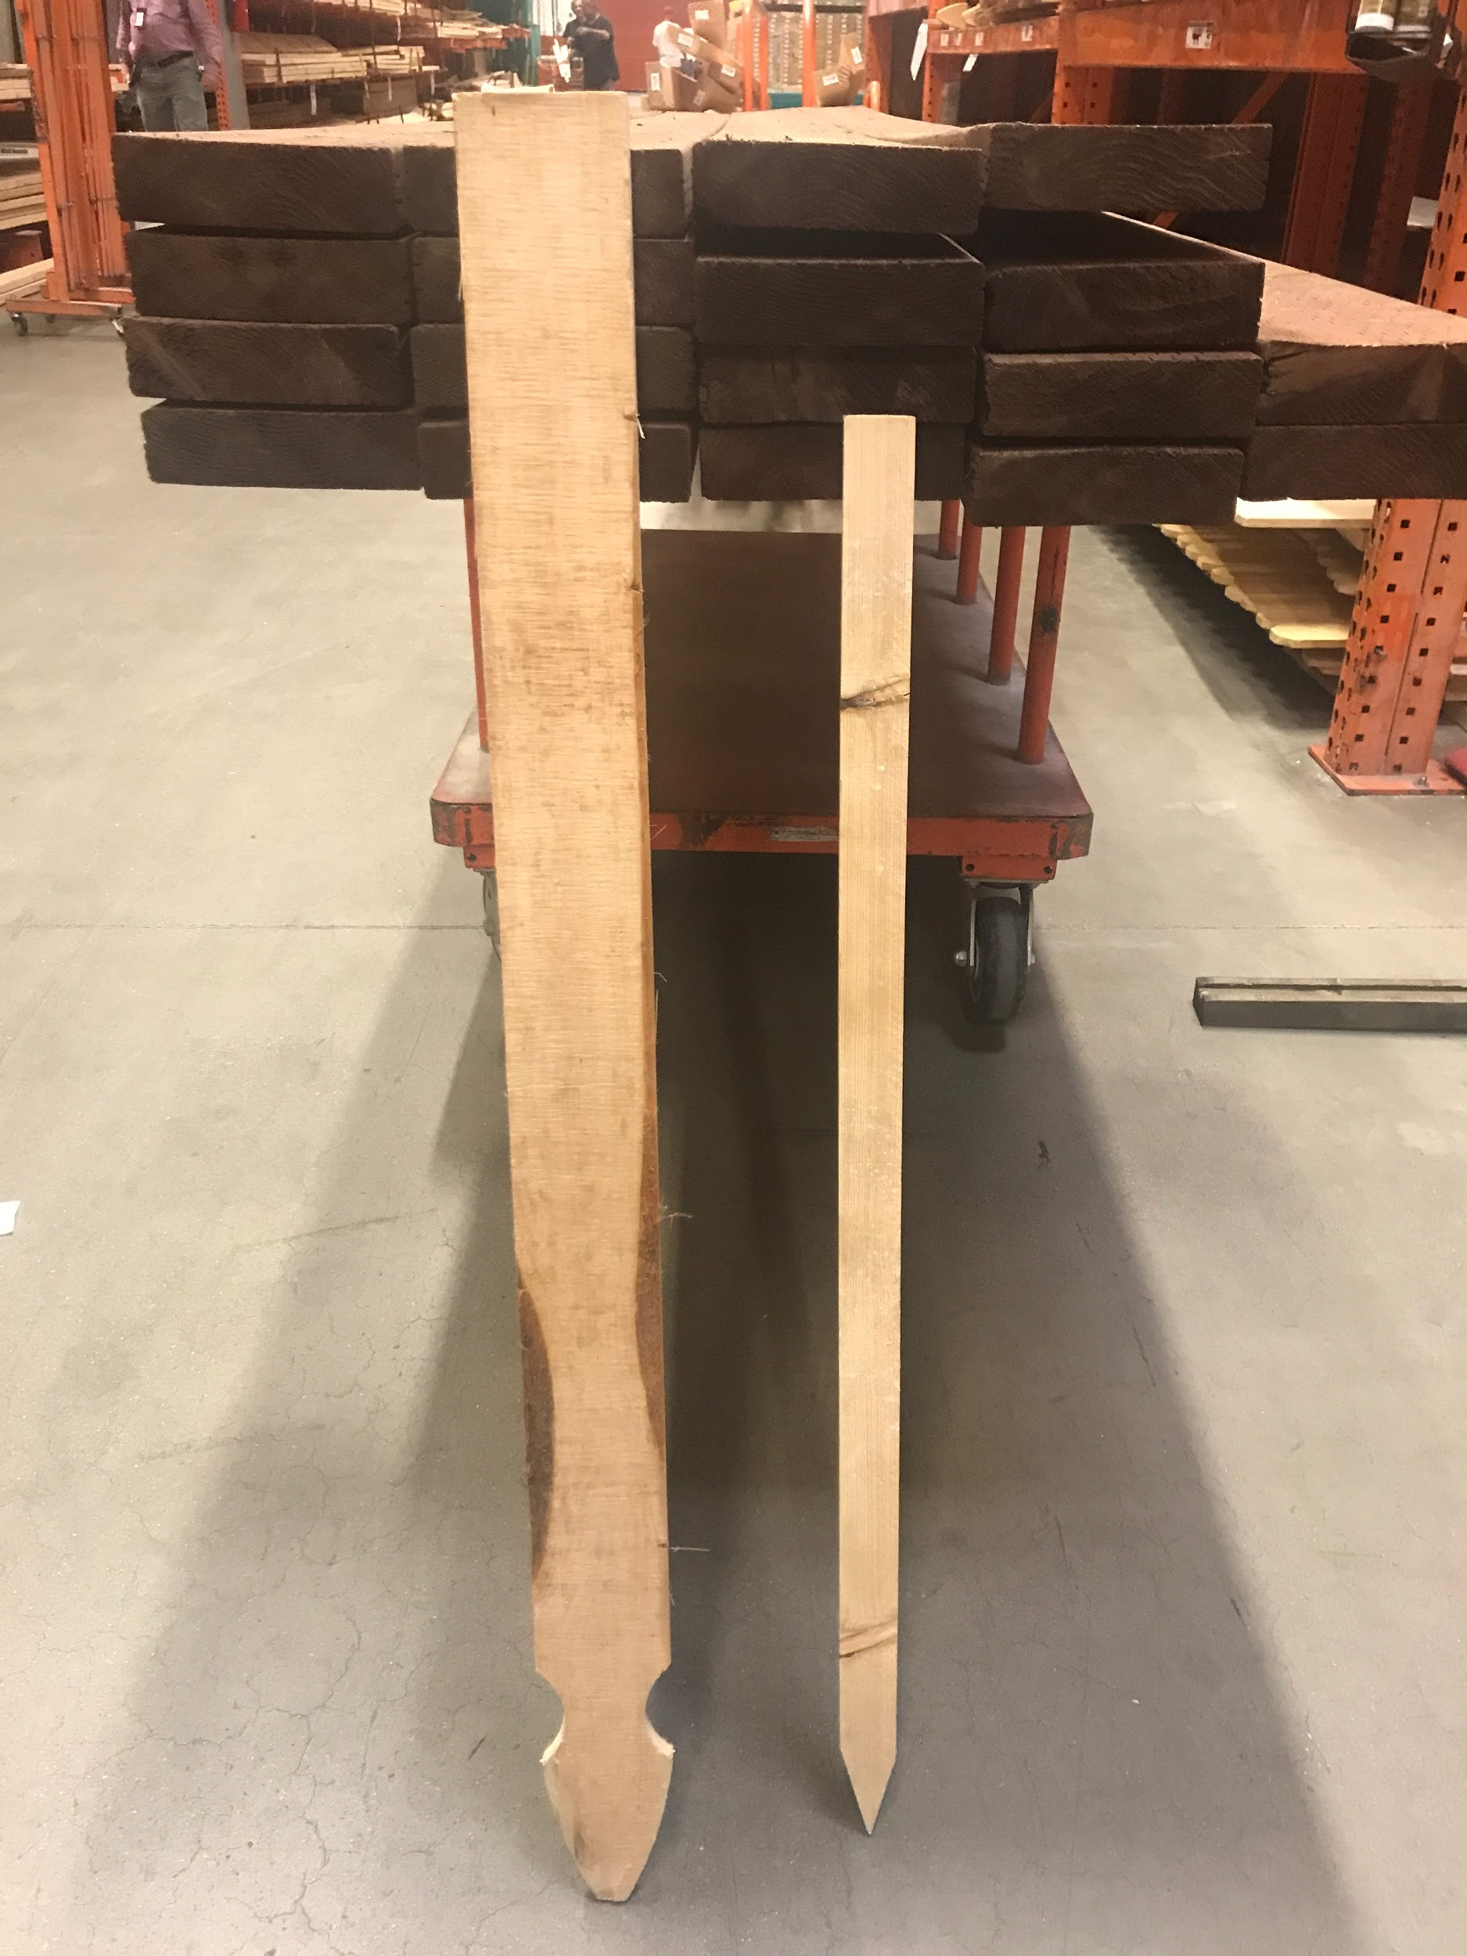
Long stakes  (flat on each end)  Height: 71 inches  Width: 3 ⅓ inches | $1.37 per stake | 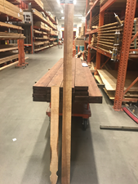 | 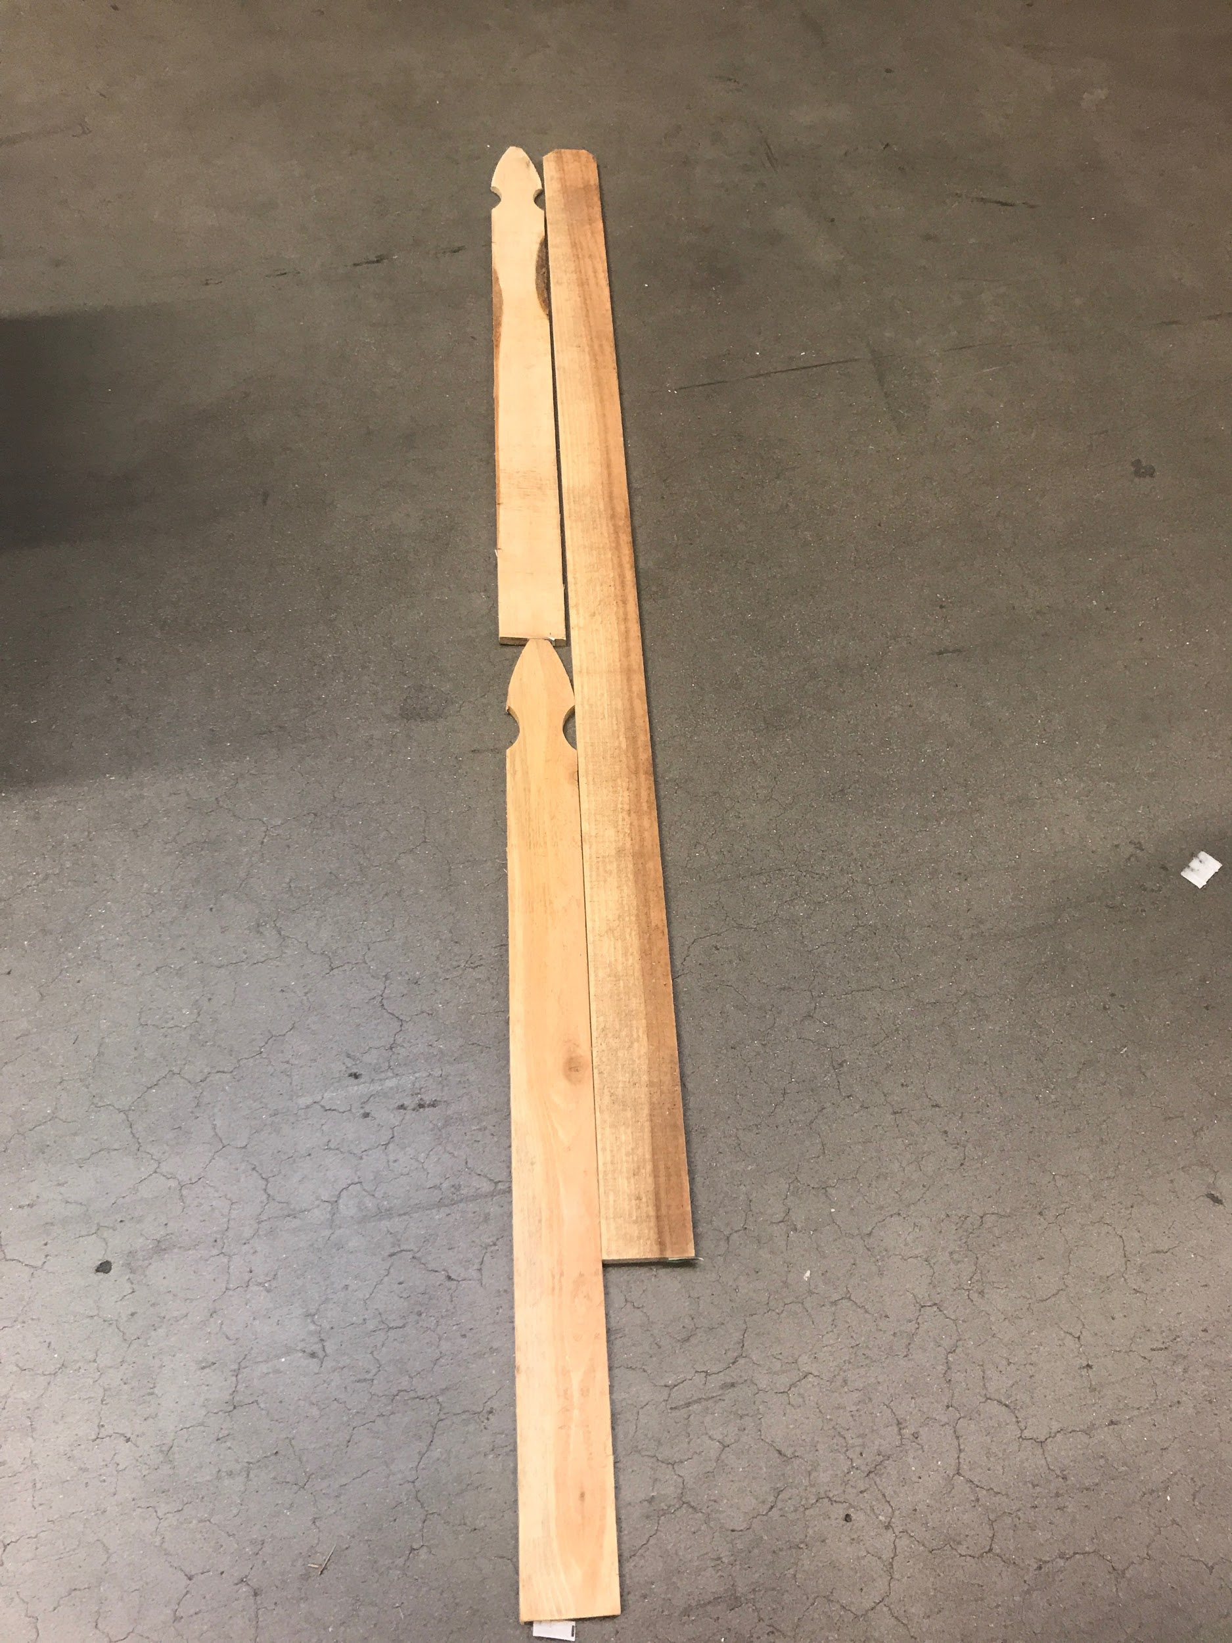
FENCING
Item | Price | Pictures | Pictures
Green Plastic Fencing  7/8” mesh  Height: 3 feet  Length: 25 feet | $23.97 per roll | 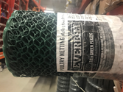 | 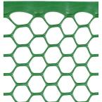
Galvinized Poultry Netting  1” mesh  20 gauge  Height: 3 feet  Length: 25 feet or 50 feet | $16.98/roll  for 25 foot roll  $30.98/roll  for 50 foot roll | 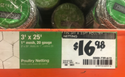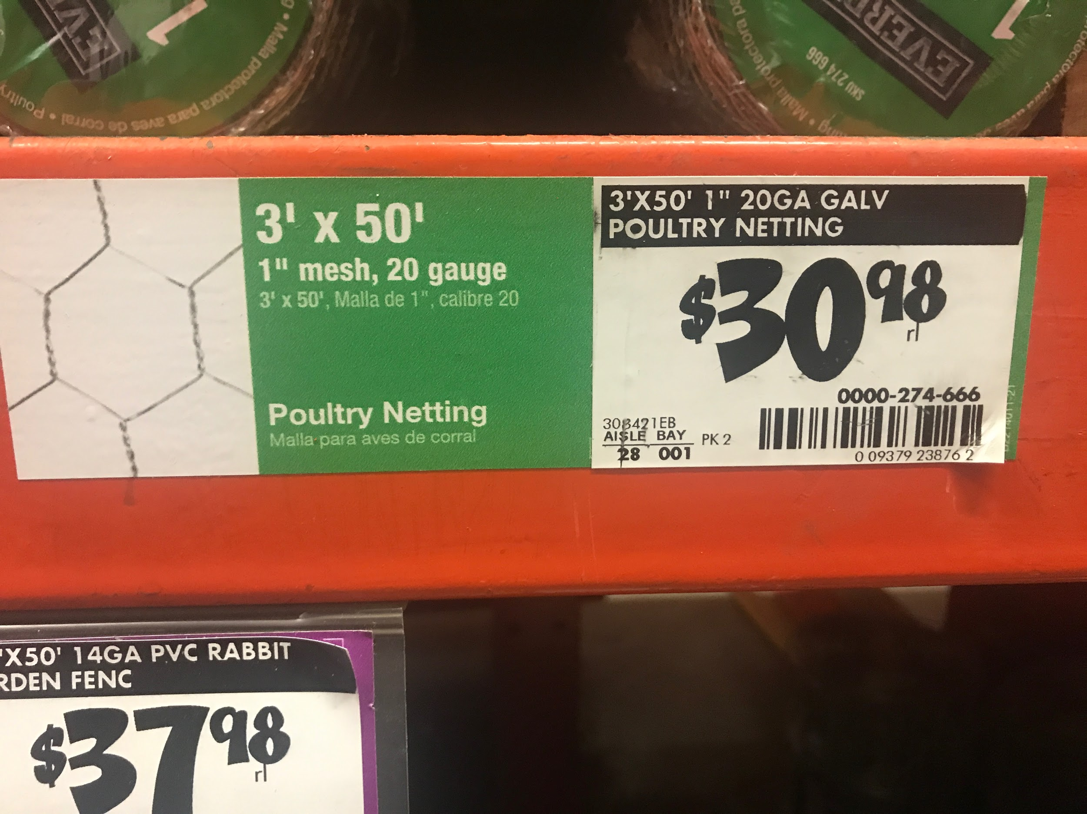 | 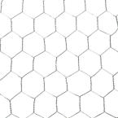
Tenax Black Plastic Hardware Net  ½” mesh  Height: 3 feet  Length: 15 feet | $31.98/roll | 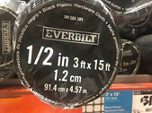
Steel Rabbit Garden Fence  16 gauge  Height: 2 ⅓ feet  Length: 50 feet | $27.98/roll | 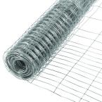

PART 4: Applying for Funding
Your class is going to apply for a grant to purchase the materials for your 4 foot by 8 foot garden plot.
You need to purchase the compost, and the fencing materials.
Convince the funder that you have a good plan for your garden, including your garden fence. Be sure to list and justify any assumptions you are making.
Tell the funder how much money your plan will cost.

