HOW MANY BOXES? Warm Up Claim Task 1 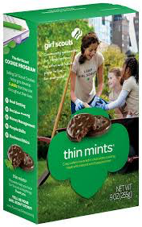

* Based on the data below showing Girl Scout Cookie Sales Last Year at the Grocery Store, the Girl Scout leader thinks that **one-half (1/2)** of the boxes that they bring to the sale should be **Thin Mints.**
* Do you agree? If so, why? If not, why not?
* If you don’t agree, what fraction of the boxes should be **Thin Mints?**
* Use fractions to justify your reasoning.

HOW MANY BOXES? Warm Up Task 2 

The Girl Scout leader is trying to estimate how many cookie boxes the Girl Scouts will sell during the 3 hour sale outside of Walmart.

Which of these **assumptions seem reasonable**? Which are unreasonable? Explain your thinking.

A) It will take about 15 minutes to sell one box of cookies

B) Some customers will buy one box of cookies, other customers will buy two or three boxes of cookies

C) In a 15 minute period, the Girl Scouts will probably sell 60 boxes of cookies.

D) In a 15 minute period, the Girl Scouts will probably have 2 to 4 different

customers.

HOW MANY BOXES?: SPECIFIC SCENARIO 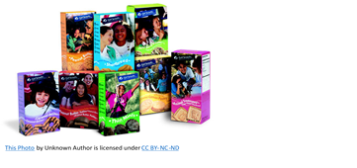

The Girl Scout Troop is going to sell cookies outside Walmart for 3 hours this Saturday.

* How many **total boxes** should they bring?
* How many **boxes of each kind of cookie** should they bring?
* What **portion of the total** number of boxes should be Thin Mints, Samoas, Do-si-Dos, etc.. (use *fractions and/or percents*)
* Explain how you used the data to support your decisions.
* Explain any assumptions that you made.

*Adaptation*: The Girl Leader says she can bring no more than 200 boxes to the sale. Will this be enough? Adjust your model.

Data Option 1a:  
Girl Scout Cookie Sales Last Year at Grocery Store

|  |  |
| --- | --- |
| **Cookie** | **Number of Boxes (100 total)** |
| Thin Mints | 25 |
| Samoas | 20 |
| Tagalongs (PB Patties) | 15 |
| Smores | 15 |
| Do-si-dos (PB Sandwich) | 10 |
| All Others | 15 |

Data Option 1b:  
Girl Scout Cookie Sales Last Year at Grocery Store

|  |  |
| --- | --- |
| **Cookie** | **Number of Boxes (50 total)** |
| Thin Mints | 13 |
| Samoas | 10 |
| Tagalongs (PB Patties) | 8 |
| Smores | 7 |
| Do-si-dos (PB Sandwich) | 5 |
| All Others | 7 |

Data Option 2: Favorite Girl Scout Cookie: Survey of Friends and Family

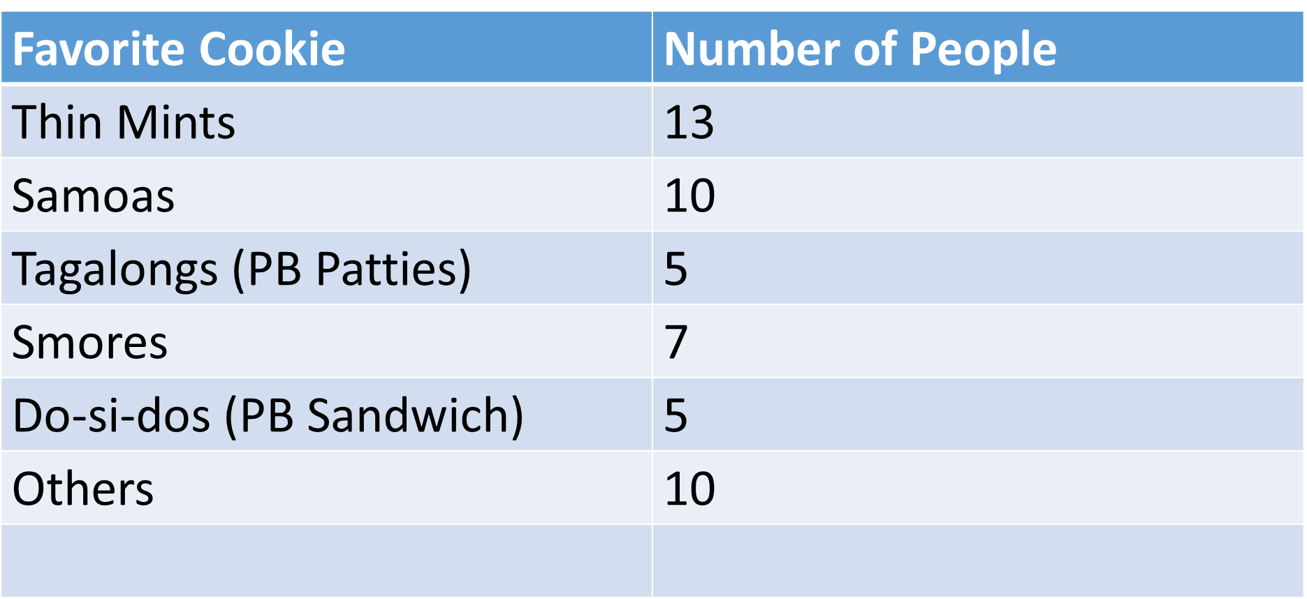

Data Option 3: National Sales Data from 2016

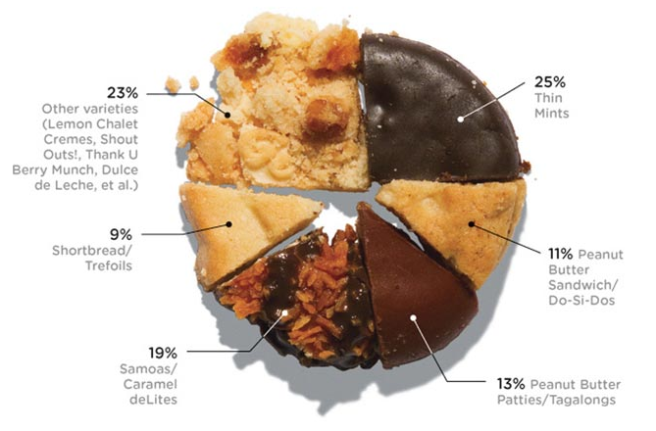

**Girl Scout Cookie Sales Data**

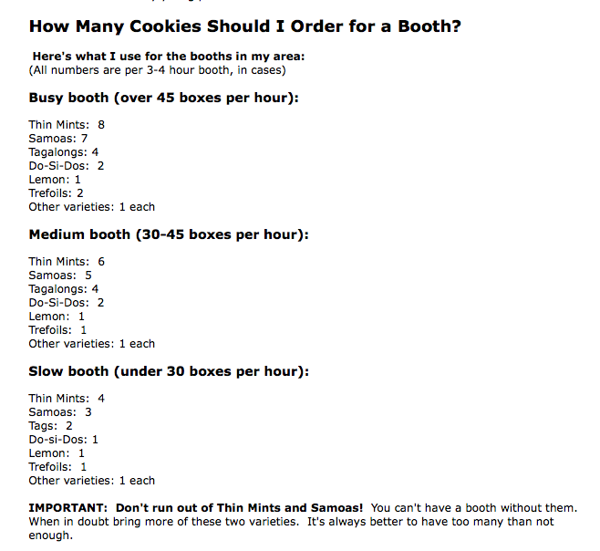

PROFITS TASK: The Girl Scout Troop wants to estimate how much profit their troop will make when they sell boxes of girl scout cookies at the grocery store?

What do you know that could help you figure this out?

What do you need to know?

What assumptions will you have to make?

Profit Task: What do you notice? What do you wonder?

How could this information help you?

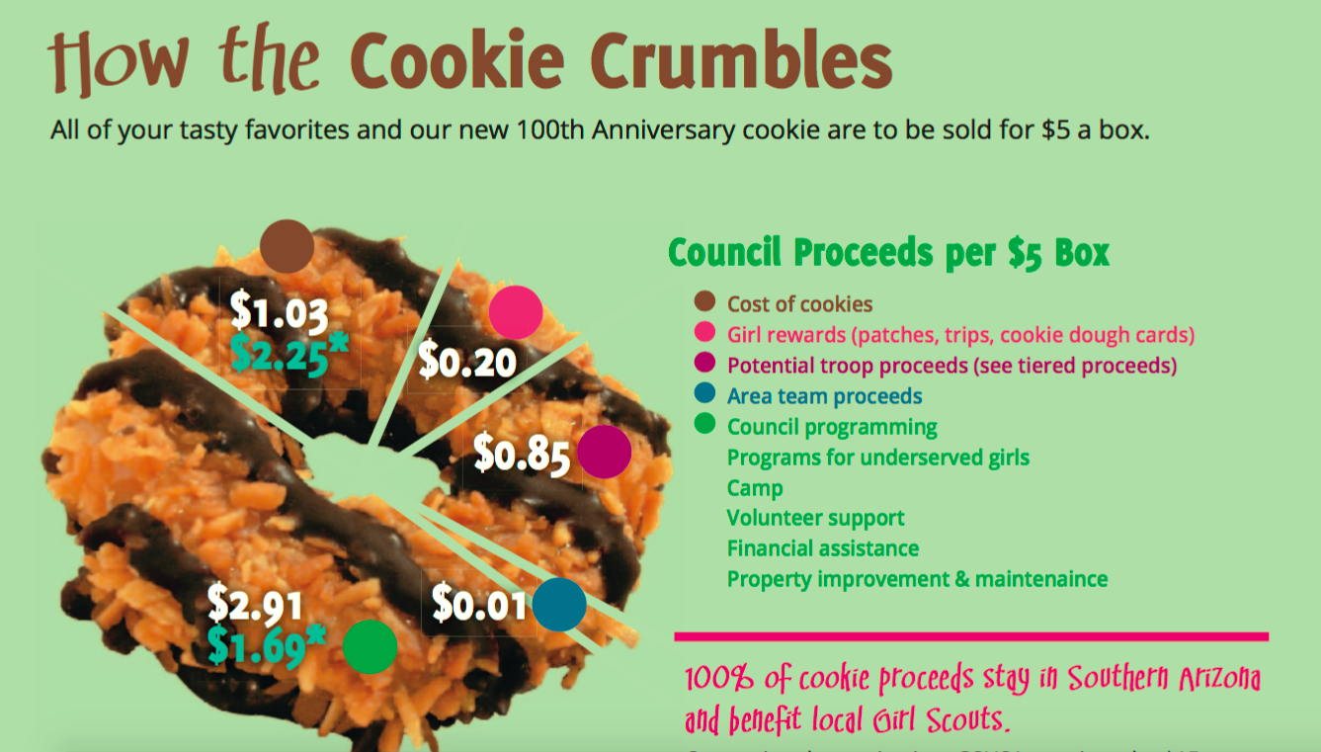

**\* Some specialty cookies (Toffee-Tastic and S’mores) cost more. * Property costs vary.**

**Girl Scouts of Southern Arizona Website (2017)**

Estimate the profits that the Girl Scout Troop with make (for their troop) when they sell girl scout cookies at the grocery store.  
  
Explain your estimate using words, numbers and calculations.  
Identify and explain each of the assumptions that you made.  
Explain how changing your assumptions would change your estimate.