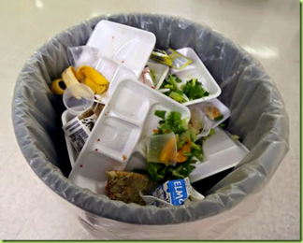
Cafeteria Waste
Your class wants to help your school reduce cafeteria waste. Before you can make any recommendations to the Principal, you need to know what kinds of trash are created in the cafeteria and how much of each kind are wasted.
- How could you study cafeteria waste?
- What questions could you ask?
- How would you answer them?
- Who could help you answer these questions?
- What mathematics would you use?
- Make a plan to answer your questions.
- Carry out your plan and make a presentation describing what you learned.

Cafeteria Waste
Your class wants to help your school reduce cafeteria waste and has decided to look at the amount of trash created by using disposable trays.
- How can you determine the amount trash created by disposable trays?
- Who could help you answer these questions? Cafeteria workers? Custodians?
- What mathematics would you use?
- Make a plan to answer your questions.
- Carry out your plan and make a presentation describing what you learned.

Students at your friend’s school claim that they waste enough disposable trays in a month to fill their classroom. Another school said that if they stacked their disposable trays for four weeks, the stack would be as tall as a five-story building. Are these reasonable claims?
Can you relate the amount of waste created by disposable trays in your school to the size of your classroom or school building?

